**Travel to the United States (USA) or to a Foreign Country: Release Waiver**

**(HOST PARENT FORM)**

Student Name ____________________________________________________________________

Last First Middle

I/we, the undersigned host parent(s) of the above referenced student take full supervision responsibility of said student to travel out of country as outlined below. As a result, and knowing this is an extraordinary situation, we release the School District 71 Comox Valley International Student Program, the school district and its employees from any responsibility for the safety or welfare of this student. I/we also understand and agree that prior to and upon leaving Canada and the School District 71 program:

* we verify that the student was not pressured to participate in this trip;

* we will ensure that the natural parents and/or guardians of this student have sent their original copy of the notarized release waiver to the District Principal;

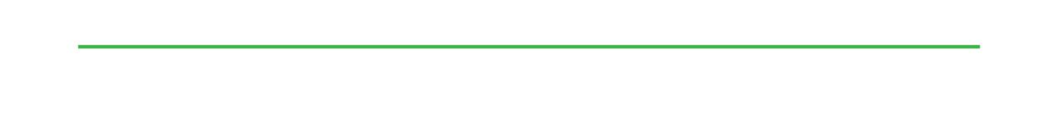

* we release School District 71 and its employees, agents, directors and attorneys/solicitors from any and all liability damages or injuries incurred by this student during the entire period of this travel; and

* we indemnify and hold harmless School District 71, its employees, agents, directors, attorneys/solicitors and insurers from any and all claims, expenses and attorney fees arising in connection with any damage or injury to our student during the entire period of this travel.

Agreed and accepted this _______ day of _________________, 20____.

_____________________________________ ________________________________

Host Parent 1 (full name) Host Parent 1 (signature)

_____________________________________ ________________________________

Host Parent 2 (full name) Host Parent 2 (signature)

|  |
| --- |
| In the case of our family trip with this student, the planned itinerary out of country from the School District 71 program is as follows:  Destination:  Adult(s) responsible for our child at the destination:      Date leaving: Flight(s):      Date returning: Flight(s):      Hotel: Address:  Contact information:  Notarization area: |